**CHAPTER 3**

**METHODOLOGY**

This chapter explains about the methodology that are being implemented. The project implements the waterfall model which is the classic model of software engineering (Munassar, N., M., A. & Govardhan, A., 2010). This chapter will explain about what is waterfall model, the phases involved, the processes and activities that were done during the each of the phases and the deliverables that will be produced for each of the phases.

* 1. **Waterfall Model**

Waterfall model is the first and the oldest model that was being introduced as part of the Software Development Life Cycle (SDLC) approach that was used in software development (Munassar, 2010; Sharma, 2016). Waterfall model is one of the simplest and easiest to understand SDLC (Sharma, 2016). It emphasizes planning before development to ensure the detection of possible flaw before the system are being built and this model works well for a quality concerned project. Figure 3.1 shows the phases of SDLC involved in waterfall model.

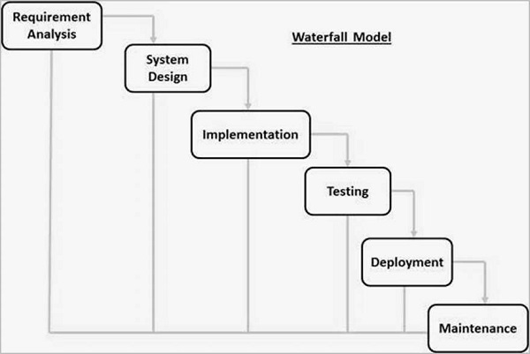

**Figure 3.1** General overview of waterfall model

(*Source:* TutorialsPoint, 2017)

Waterfall models are divided into multiple phases and progress of the phases are seen as flowing downwards like a waterfall (Sharma, 2016). Each phases in the waterfall model begins only if the previous phase has been completed and the previous phase’s output act as the input for the next phase (Sharma, 2016).

The phases that this project will be following is based in Figure 3.1.1, which is Requirement Analysis, System Design, Implementation and Testing. Both Deployment and Maintenance phase will not be executed by this project because the objective of this project is up until to validate the accuracy of the output with the actual election data.

* + 1. **Requirements Analysis**

The objective of requirement analysis phase is to analyze and understand the requirement for the system and produce the specification for that particular system (Sharma, 2016).

The activities that were being done during this phase is determining the problem of current Malaysia election data visualization, determine the similar system that has been implemented by other countries such as United States (US), United Kingdom (UK), Australia and India. Based on the similar system, the project comes out with a specific solution in order to solve the stated problems. The problem of current Malaysia election are most of it were presented in tabular format, simple graphs or charts, were not interactive and the data visualization output cannot dynamically change according to inputs.

The deliverables that were produced during this phase is the completion of the first objective as stated in Chapter 1, to identify the suitable data visualization technique for Malaysian Election Data. The suitable data visualization techniques that were explained in Chapter 2 is hexagon tile grid map with the approach of interactivity and dynamic ability of the map, presenting a basic representation first before presenting a more complex representation and present a combinations of map and bar chart. Figure 3.2 shows the objectives, activities and deliverables that will be produced during this phase. Figure 3.3 shows the use case diagram for this project.



**Figure 3.2** Objectives, activities and deliverables for Requirement phase.

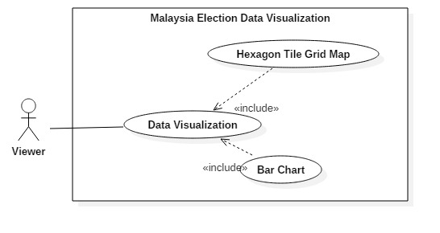

**Figure 3.3** Use Case diagram for the requirement of the project.

* + 1. **System Design**

The objective of System design phase is to study each of the requirements stated in the Requirement Analysis phase and produce a system design for the expected system (Sharma, 2016).

The activities that were done during this phase is designing the system architecture and the sequence of activities that a user will be going through when using the system, determine the technology that will be used for the development of the system and designing the User Interface (UI) of the system.

The deliverables that were produced during this phase is the half-completion of this project second objective as stated in Chapter 1, to construct the application on the chosen data visualization technique. In addition, this phase will also produce architecture diagram and it’s documentation for the system and UI design and mockups. The technology that were used for the development of this system is Hypertext Markup Language (HTML), Cascading Stylesheet (CSS), Scalable Vector Graphic (SVG), JavaScript, Data Driven Document (D3.js) which is a JavaScript library manipulating document based on data and JavaScript Object Notation (JSON) which is a lightweight data-interchange format. Figure 3.4 shows the stated objectives, activities and deliverables that will be produced during this phase. Figure 3.5 shows the overall architecture of the system.



**Figure 3.4** Objectives, activities and deliverables for System Design phase.

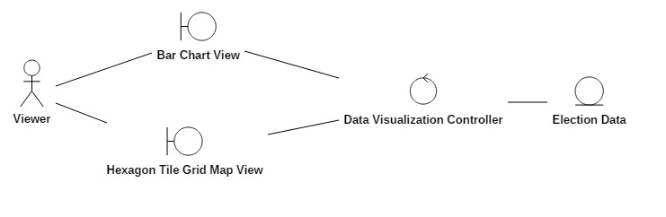

**Figure 3.5** Overall architecture diagram of the system.

* + 1. **Implementation**

The objective of the Implementation phase is to develop the designed system as in System Design phase.

The activity of this phase is to implement the system in small unit first before integrating all of the units to form a full system (Sharma, 2016). The development of the system will be based on the data visualization process as stated by Fry (n.d.). The data visualization process is:

1. Acquire
2. Parse
3. Filter
4. Mine
5. Represent
6. Refine
7. Interact

In acquire process, the system will retrieve the election data from JSON file. In parse process, the system will generate a structure from the retrieved data, for example, order the election data by parliaments. In filter process, the system will remove all data except the required data for a particular purpose, for example, only the data for BN party will be selected. In mine process, the system will apply statistical method in order to produce the pattern of the data, for example, calculate the percentage of seats won by certain party. In represent process, the system will represent the data in a basic visual model, for example, showing the bar chart that shows the ratio number of seats won by certain party. In refine process, the system will improve the basic visual, for example, make use of a certain color that represent the color of a particular party. In interact process, the system will implement a way for the viewer to interact with the data, for example, the viewer can view a description of the political condition on a certain parliament when they hover over a tile in the hexagon tile grid map.

The deliverables of this phase is the completion of the second objectives of this project as stated in Chapter 1, to construct the application on the chosen data visualization technique, and the finished prototype of the system. The prototype should implement all of the functionalities as designed in the Design phase. Figure 3.6 shows the stated objectives, activities and deliverables that will be produced during this phase.



**Figure 3.6** Objectives, activities and deliverables for System Design phase.

* + 1. **Testing**

The objective of this phase is to test the developed prototype system so that it meets the required functionality as designed in Design phase and as stated in Requirement Analysis phase.

The activities of this phase is to do a unit testing for all of the visuals in the system, do an integration testing for the whole system and do verification for the correctness of the visual produced against the actual data.

The deliverables of this phase is the completion of the third objective of this system as stated in Chapter 1, to validate the accuracy of the visual with the actual data. Figure 3.7 shows the stated objectives, activities and deliverables that will be produced during this phase.



**Figure 3.7** Objectives, activities and deliverables for System Design phase.

* 1. **Chapter Summary**

This chapter explains about what method that were being implemented in order to develop this project and each of the phases in the methods were explained in detail. This project implements the Waterfall Model. Waterfall Model is the basic Software Development Life Cycle (SDLC). The phases in this model is Requirement Analysis, System Design, Implementation, Testing, Deployment and Maintenance. However, this project will not be going to implement the Deployment and Maintenance phase the objective of this project is up until to validate the accuracy of the output with the actual election data.